


Faculty of Computer Applications & Information Technology

Integrated Master of Science (IT) – iMSc(IT) Programme

Semester IX

Project Report for 221601903 Robotic Process Automation

“Project Title”

Submitted by:

Group No:
Student1 Name, Enrolment No Student2 Name, Enrolment No

TABLE OF CONTENTS
The following table outlines the complete formal structure of this Robotic Process Automation Project Report, detailing all primary sections, functional breakdowns, and corresponding deliverable domains.
Section No. | Report Section & Sub-Modules | Deliverable Scope
1.0 | Introduction  1.1 Background of the Process & Organization  1.2 Business Scenario & Core Personas | Phase 1
2.0 | Problem Statement & Objectives  2.1 Problem Statement & Operational Bottlenecks  2.2 Project & Automation Objectives (SMART) | Phase 1
3.0 | Existing Manual Process (As-Is Process)  3.1 Step-by-Step Manual Workflow  3.2 Applications & Tools Used  3.3 Bottlenecks, Inefficiencies & Pain Points Matrix | Phase 1
4.0 | Proposed RPA Solution (To-Be Automated Process)  4.1 To-Be Architecture & Redesigned Workflow  4.2 Process Optimization & Efficiency Gains | Phase 2
5.0 | RPA Tool Used (Mandatory Technical Specifications)  5.1 Tool Name & Version (Robot Framework v7.x / SeleniumLibrary)  5.2 Justification for Tool Selection  5.3 Core Features & Operational Environment | Phase 2
6.0 | Direct RPA Features Implemented (Mandatory Module)  6.1 Excel/CSV Bulk Data Ingestion  6.2 Browser Automation & Form Population  6.3 Dynamic File Uploading & Application Submission | Phase 2
7.0 | Indirect / Supporting RPA Features (Mandatory Module)  7.1 FastAPI Bot Controller & Headless Daemon Integration  7.2 React Control Portal Interface  7.3 Custom RentalAnalyzer Suitability Scoring Algorithm  7.4 Automated PDF Rulebook Generation | Phase 2
8.0 | RPA Workflow & Architecture Diagrams  8.1 System Architecture Diagram  8.2 End-to-End Robot Execution Flowchart | Phase 2
9.0 | Implementation Details  9.1 Robot Framework Suites Breakdown  9.2 Keyword Architecture & Data Locators  9.3 RentalAnalyzer Python Library Deep-Dive | Phase 3
10.0 | Visual Proof & Screenshots  10.1 Portal UI & Seller Dashboard Execution  10.2 Robot CLI & Browser Automation Steps  10.3 Generated Output Artifacts & Verification URLs | Phase 3
11.0 | Testing & Test Cases  11.1 Test Strategy & Test Environment  11.2 Comprehensive Test Cases Matrix (Positive & Negative)  11.3 Execution Traceability & Verification Logs | Phase 4
12.0 | Results & Performance Metrics  12.1 Execution Time & Throughput Benchmark  12.2 Output Files & Audit Log Validation | Phase 4
13.0 | Before vs. After Comparison  13.1 Quantitative SLA & Time Savings Analysis  13.2 Error Rate Elimination & Operational ROI | Phase 4
14.0 | Benefits Realized  14.1 Operational, Strategic & Regulatory Advantages | Phase 5
15.0 | Limitations & Challenges Encountered | Phase 5
16.0 | Future Scope & Potential Cognitive AI Expansions | Phase 5
17.0 | Conclusion & References | Phase 5

1.0 INTRODUCTION
1.1 Background of the Process and Organization
In the contemporary real estate ecosystem, the surge in urbanization and digital commerce has fundamentally reshaped property leasing and property acquisitions. Real estate portals and property management organizations handle thousands of daily transactions spanning property inventory updates, buyer inquiries, rental applications, and tenant credential verification. Traditionally, property management agencies and independent landlords rely on heavily manual, fragmented processes to execute these workflows. Operators spend substantial portions of their working hours manually copy-pasting property specifications into listing engines, reviewing applicant emails, inspecting financial documents, calculating affordability ratios, and manually updating disparate database records.
Plotify Real Estate is an advanced, full-stack property technology platform engineered to bridge the divide between property owners (sellers/landlords) and prospective tenants (buyers/renters). Designed as a modern peer-to-peer property marketplace, Plotify provides dynamic listing modules, dedicated role-based portals, and an end-to-end rental application gateway. However, as transactional velocity accelerates, the administrative burden on property owners escalates sharply. Evaluating each prospective tenant requires cross-referencing employment status, monthly income disclosures, property rental valuations, and identity documents—an operational overhead that frequently introduces substantial delays, subjective bias, and human data-entry errors.
Robotic Process Automation (RPA) emerges as a transformative paradigm to resolve these operational bottlenecks. By deploying rule-governed software bots capable of mimicking human keyboard, mouse, and browser interactions, RPA eliminates low-value, repetitive administrative tasks. In this project, an enterprise-grade RPA bot developed with Robot Framework and SeleniumLibrary is integrated into the Plotify Real Estate ecosystem. The automation bot assumes complete operational responsibility for ingesting bulk property inventories, executing seamless tenant application workflows, performing automated financial underwriting and suitability scoring, updating dashboard records, and generating structured compliance audit reports.
1.2 Description of the Business Scenario and Core Personas
The business scenario addressed by this project reflects an authentic high-velocity residential leasing operation where speed, accuracy, and rigorous applicant qualification dictate financial success. In a standard operating cycle, three key entities interact within the system:
1. Property Sellers / Landlords: Represent property owners, real estate developers, and rental landlords who need to market property assets, review submitted tenant dossiers, and issue binding lease approvals without administrative friction.
2. Prospective Tenants / Renters: Represent prospective occupants seeking rental accommodations. Applicants browse verified listings, submit formal rental applications, disclose sensitive financial data (employment designation, monthly earnings), and upload identity and financial verification files.
3. Autonomous RPA Software Bot: An autonomous digital agent built on Robot Framework that operates continuously. The bot consumes bulk property inventories from structured CSV sheets, submits end-to-end applicant dossiers, executes programmatic credit/suitability underwriting through a custom Python analyzer, updates application workflow statuses on the seller portal, and exports auditable CSV ledgers.
By replacing human administrative handlers with an autonomous RPA robot, Plotify transitions from a labor-intensive, bottleneck-prone portal into a touchless, high-efficiency digital real estate marketplace.
2.0 PROBLEM STATEMENT & AUTOMATION OBJECTIVES
2.1 Problem Statement and Operational Bottlenecks
Prior to the introduction of Robotic Process Automation, the operational lifecycle of property listing ingestion and tenant application processing within the Plotify environment was characterized by severe manual dependencies. The existing manual approach suffered from four critical operational deficiencies:
1. Prolonged Application Turnaround Latency: Manual verification of applicant credentials, income proofs, and bank statements took between 24 to 48 hours per submission. In high-demand metropolitan markets, qualified prospective tenants routinely abandoned pending applications due to prolonged turnaround times, creating artificial vacancy loss for landlords.
2. Subjective Underwriting and Calculation Inconsistencies: Human leasing officers manually evaluated rent-to-income affordability using desktop calculators or ad-hoc mental estimation. Because different evaluators applied divergent risk thresholds, applicant scoring was highly inconsistent, vulnerable to subconscious bias, and prone to mathematical error.
3. Labor-Intensive Bulk Inventory Ingestion: Landlords and institutional property brokers managing dozens of units were forced to manually key in over seventeen discrete attributes per listing (including furnishing status, facing direction, floor level, amenity strings, and physical file paths) through web forms. This manual entry consumed several hours per catalog and suffered from a 12% to 18% typo rate.
4. Disconnected Audit Trails and Reporting Silos: Approved and rejected applicant records remained trapped inside database tables without standardized, automated export mechanisms. Property managers manually copied data into local spreadsheets, creating disjointed data silos, reconciliation discrepancies, and total absence of verifiable execution logs.
2.2 Project and Automation Objectives
The primary objective of this project is to conceptualize, engineer, and deploy a comprehensive Robotic Process Automation system that eliminates manual human intervention across the property listing and rental evaluation lifecycles. Following strict SMART (Specific, Measurable, Achievable, Relevant, Time-bound) engineering principles, the project establishes the following core objectives:
Objective 1 — Touchless Bulk Property Ingestion: To construct a dedicated Robot Framework suite (auto_list_bulk.robot) that parses external CSV catalogs, validates mandatory fields, matches UI dropdown options, handles dynamic file uploads, and publishes properties with zero human intervention.
Objective 2 — Autonomous Application Submission & Document Ingestion: To orchestrate end-to-end applicant simulation (auto_apply.robot and rpa_bot.robot) that automatically authenticates tenant accounts, navigates active listings, populates application web forms, dynamically creates test verification PDFs, and submits completed KYC packets.
Objective 3 — Algorithmic Financial Underwriting & Suitability Scoring: To develop a custom, reusable Python library (RentalAnalyzer.py) natively integrated with Robot Framework to parse messy currency formatting, calculate rent-to-income percentages, enforce rule-based employment deductions, and return an objective 1-10 suitability score.
Objective 4 — Automated Dashboard State Transition: To automate the seller review workflow (auto_approve.robot) where the bot navigates the seller dashboard, queries pending applications, applies the algorithmic suitability score into the application record, and transitions the state from 'Pending' to 'AI Reviewed' or 'Approved'.
Objective 5 — Automated Audit Reporting & Data Extraction: To implement automated web-scraping keywords (auto_export_csv.robot and buyer_export.robot) that harvest all approved application metrics from the web UI and append formatted records into standardized CSV ledgers (approved_applications_report.csv and buyer_approved_properties.csv) for management accounting.
3.0 EXISTING MANUAL PROCESS (AS-IS PROCESS)
3.1 Step-by-Step Manual Workflow
To fully comprehend the operational necessity and impact of the RPA solution, the baseline 'As-Is' manual procedure was mapped in detail. In the legacy manual paradigm, a typical operational cycle unfolded across six sequential stages:
Stage 1 — Manual Listing Data Entry: When a property owner wished to register rental units, an administrative clerk manually gathered paper brochures or unformatted Excel sheets. The clerk logged into the web portal, navigated to the listing creation interface, and manually typed 17 distinct property parameters. Each property photograph and ownership deed had to be manually browsed from local file directories and uploaded.
Stage 2 — Application Receipt & Manual Queueing: Interested applicants navigated the portal, manually filled out personal details, and manually attached scanned copies of identity cards, income statements, and bank proofs. These submissions sat in an unmonitored inbox until a leasing agent initiated a review.
Stage 3 — Manual Document Verification: The human agent opened each submission, downloaded multiple PDF attachments, visually inspected the authenticity of the documents, and transcribed financial figures into a local notepad or desk calculator.
Stage 4 — Manual Affordability Calculation: The agent manually calculated the ratio of monthly rent against stated monthly income. If the ratio exceeded 30%, the agent manually applied mental penalties. Depending on whether the applicant was full-time employed, self-employed, or a student, the agent formed a subjective judgment regarding creditworthiness.
Stage 5 — Manual Dashboard Status Update: The agent logged into the seller administration portal, located the applicant in a tabular list, clicked the status dropdown, selected 'Approved' or 'Rejected', typed personal assessment remarks, and clicked submit.
Stage 6 — Manual Spreadsheet Data Compilation: Finally, to maintain internal office records, the agent re-opened a master Excel tracking workbook, manually re-typed applicant names, contact information, property titles, and approval statuses row-by-row.
3.2 Applications and Software Used in the Manual Process
In the manual 'As-Is' workflow, human operators constantly context-switched across multiple disjointed software applications. The standard desktop software suite utilized by leasing officers included:
• Web Browsers (Google Chrome / Mozilla Firefox): Used to access the Plotify web application, fill web forms, and review tabular dashboard listings.
• Email Clients (Microsoft Outlook / Webmail): Used to receive applicant notifications, communicate with landlords, and forward document files.
• Spreadsheet Applications (Microsoft Excel / Google Sheets): Used to maintain local offline applicant ledgers, property logs, and transaction registries.
• Document Viewers (Adobe Acrobat Reader): Used to open, zoom, and inspect submitted identity proofs, salary receipts, and bank verification files.
• Desktop Calculator Tool: Used for arithmetic calculation of rent-to-income percentages and income deductions.
3.3 Bottlenecks, Inefficiencies, and Pain Points Matrix
The manual 'As-Is' workflow was afflicted with severe operational bottlenecks that throttled business scalability and compromised operational reliability. The key pain points identified during process analysis include:
• Excessive Time Expenditure & Low Throughput: Because each manual application review required 25 to 45 minutes of dedicated human effort, a leasing officer could process at most 12 to 15 applications per business day. Surges in listing inquiries generated substantial backlog queues.
• Data Integrity Risks & Transcription Typos: Copying alphanumeric data (applicant names, phone numbers, email addresses, property rental amounts) across web forms, calculators, and spreadsheets generated frequent transcription errors.
• Absence of Underwriting Standardization: Because human evaluators applied variable standards to employment risk, two applicants with identical financial profiles often received contradictory decisions depending on which agent handled the review.
• Regulatory & Compliance Audit Deficit: No centralized, machine-readable execution log existed to prove when an application was reviewed, who performed the calculation, or what exact formula was applied, leaving the organization vulnerable during landlord audits.
Table 1.1: Operational Analysis of Manual 'As-Is' Workflow Activities
Step # | Activity Name | Actor | Software Used | Avg. Time | Error Risk & Impact
Step 1 | Property Listing Data Entry | Clerk / Landlord | Chrome / Web Portal | 15 - 25 min | High: Missing attributes, invalid formatting, wrong image paths
Step 2 | Application Ingestion & Intake | Applicant / Clerk | Chrome, Email | 10 - 15 min | Moderate: Incomplete dossiers, unreadable attachments
Step 3 | Document Verification | Leasing Agent | Adobe Acrobat | 8 - 12 min | Moderate: Missed forged dates, unverified income proofs
Step 4 | Affordability Calculation | Leasing Agent | Desk Calculator | 5 - 10 min | High: Arithmetic error, inconsistent underwriting standards
Step 5 | Dashboard Status Update | Leasing Agent | Chrome / Seller Portal | 3 - 5 min | Low: Selecting wrong dropdown value or wrong tenant row
Step 6 | Master Spreadsheet Logging | Leasing Agent | Microsoft Excel | 5 - 8 min | High: Typographical errors, skipped records, formula breaks
As demonstrated in Table 1.1, the cumulative human time expended per single rental application averaged 46 to 75 minutes. When scaled to a commercial portfolio processing dozens of properties weekly, the manual procedure demanded multiple full-time administrative staff, inflicted severe business latency, and created substantial financial risk through unmitigated human error. This exhaustive analysis underscores the urgent requirement for an autonomous, rule-governed Robotic Process Automation system.
4.0 PROPOSED RPA SOLUTION (TO-BE AUTOMATED PROCESS)
4.1 To-Be Architecture and Workflow Redesign
The proposed Robotic Process Automation (RPA) solution completely reimagines and re-engineers the residential property listing and rental evaluation lifecycle. By introducing an autonomous, software-driven digital workforce, the 'To-Be' automated process establishes a touchless, high-velocity operational pipeline. Rather than relying on human leasing officers to perform repetitive browser actions, manual data entry, calculator calculations, and spreadsheet copy-pasting, the entire lifecycle is orchestrated by Robot Framework bots operating in synergy with specialized backend libraries.
Under the redesigned 'To-Be' architecture, the process is partitioned into five synchronized, autonomous stages:
1. Autonomous Bulk Property Ingestion: The bot reads standardized CSV catalogs containing comprehensive property attributes (pricing, category, dimensions, room counts, amenities, and local media paths). The bot autonomously validates data structure, accesses the seller listing portal, populates all web form controls, attaches image files and ownership deeds, and posts verified listings within seconds.
2. End-to-End Tenant Application Simulation: The bot logs into prospective tenant accounts, applies targeted category and budget filters, extracts matching property details, dynamically generates required PDF verification files (identity proofs, income documentation, bank statements), and submits comprehensive rental applications.
3. Deterministic Underwriting & Suitability Scoring: Upon receiving new applications, the bot authenticates into the seller administrative dashboard, navigates to the incoming applications queue, extracts applicant credentials (employment status, stated income, property rent amount), and passes these variables into an algorithmic underwriting engine.
4. Real-Time Status Propagation: A specialized Python underwriting module (RentalAnalyzer) executes mathematical affordability evaluations, checks rent-to-income thresholds, penalizes employment vulnerabilities, and outputs an objective suitability score (1-10) accompanied by descriptive underwriting remarks.
5. Touchless Audit Ledger Generation: The bot inputs the calculated score directly into the administrative remarks field, toggles the application status from 'Pending' to 'AI Reviewed' or 'Approved', commits the update, and immediately scrapes the finalized transaction details into audit-compliant CSV ledgers.
4.2 Process Optimization and Operational SLA Transformation
The transition from the legacy 'As-Is' manual procedure to the 'To-Be' automated workflow eliminates structural latency and enforces absolute standard operating procedure compliance. A prospective tenant application that previously languished for 24 to 48 hours is now ingested, underwritten, scored, and logged within 30 to 45 seconds—representing an operational efficiency gain exceeding 98%. Furthermore, because the underwriting algorithm is deterministic, subjectivity, subconscious bias, and mathematical arithmetic errors are 100% eliminated.
5.0 RPA TOOL USED (MANDATORY TECHNICAL SPECIFICATIONS)
In strict compliance with project submission guidelines, this section provides an exhaustive technical specification of the Robotic Process Automation tool selected, its structural architecture, versioning details, environment configurations, and the definitive rationale for its architectural selection over commercial alternatives.
5.1 Name of RPA Tool and Exact Version Specifications
The primary automation platform deployed for this project is Robot Framework, an industry-standard, open-source automation engine renowned for its modular keyword-driven architecture, cross-platform capabilities, and extensive extensibility.
Table 5.1: Software Stack and Core RPA Tool Versioning
Stack Component | Specific Name | Active Version | Functional Purpose
Core RPA Framework | Robot Framework | 7.5 | Core keyword execution, test runner & logging engine
Browser Automation Library | SeleniumLibrary | 6.9.0 | Web DOM element location, form actions & wait logic
Browser Automation Driver | Selenium WebDriver | 4.50.0 | Low-level Chrome browser protocol communication
Runtime Environment | Python (64-bit) | 3.13.1 | Underlying programming runtime & library execution
Driver Manager Utility | webdriver-manager | 4.0.2 | Automatic ChromeDriver binary detection & resolution
Orchestration Backend | FastAPI / Uvicorn | 0.115.0 | RESTful execution endpoint & background subprocess daemon
Management Portal | React 18 / Vite 5 | 5.4.0 | Web UI for bot triggering & configuration management
5.2 Comprehensive Justification for Tool Selection
While enterprise RPA ecosystems such as UiPath, Automation Anywhere, and Blue Prism offer visual workflow canvases, Robot Framework was deliberately chosen as the optimal automation platform for the Plotify Real Estate system based on four decisive architectural pillars:
1. Zero Licensing Cost and Total Architectural Freedom: Unlike proprietary tools that demand multi-thousand-dollar annual licensing fees and rigid runtime orchestrators, Robot Framework is fully open-source under the Apache 2.0 license. This democratizes deployment, eliminates licensing overhead, and ensures complete enterprise software ownership.
2. Keyword-Driven Syntax and Readability: Robot Framework abstracts complex underlying Selenium WebDriver operations into natural, human-readable keywords (e.g., 'Open Browser', 'Input Text', 'Choose File', 'Click Element'). This keyword abstraction bridges the communication gap between business analysts, domain specialists, and automation engineers.
3. Native, Frictionless Python Extensibility: Robot Framework is implemented natively in Python. Creating custom extensions (such as the RentalAnalyzer underwriting library and ReadCsv utility) requires no complex COM bridges or external wrappers. Custom Python functions are directly exposed as first-class Robot keywords.
4. Comprehensive Forensic Reporting and Auditability: Out of the box, Robot Framework generates forensic-grade execution logs (log.html), management summary dashboards (report.html), and machine-readable data streams (output.xml). Failed keywords automatically capture full-resolution DOM screenshots, providing unmatched debugging traceability without third-party monitoring agents.
5.3 Core Features of Robot Framework Leveraged in the Project
The automation architecture heavily exploits the native strengths of Robot Framework to achieve robust, resilient web interactions:
• Advanced SeleniumLibrary Web Locators: Enables precise targeting of complex dynamic web controls across the Plotify portal using robust XPath locators, CSS classes, name attributes, and DOM attributes.
• Resilient Synchronization & Explicit Waits: Rather than utilizing brittle, hard-coded pause timers, the bot employs dynamic conditions (e.g., 'Wait Until Page Contains Element', 'Wait Until Element Is Visible') to gracefully handle asynchronous network latency.
• Native File Attachment Automation: Utilizes native Selenium file injection ('Choose File') to upload local KYC identity cards, income proofs, and bank statement PDFs directly into HTML file input tags without interacting with fragile operating system dialog modals.
• Built-in Operating System & Collections Utilities: Leverages the built-in OperatingSystem and Collections libraries to dynamically inspect file paths, verify artifact existence, manage variable scopes, and manipulate lists and dictionaries.
5.4 Operational Environment and Platform Specifications
The automation bots were engineered, verified, and executed within a modern, production-grade workstation environment configured as follows:
• Operating System: Microsoft Windows 11 Enterprise (64-bit architecture, Build 22631+).
• Python Environment: Isolated virtual environment (venv) running Python 3.13.1 with pinned dependency packages.
• Automation Browser: Google Chrome (Version 120+) paired with ChromeDriver binary dynamically managed via webdriver-manager.
• Development Environment: Visual Studio Code equipped with Robot Framework Language Server, Python IntelliSense, and Git version control.
• Target Application Host: Plotify Real Estate running on Flask 3.x with SQLite backend, hosted locally at http://127.0.0.1:5000.
6.0 DIRECT RPA FEATURES IMPLEMENTED (MANDATORY MODULE)
In strict adherence to the project criteria, this section documents the Direct RPA Features implemented within the automation suite. Direct RPA capabilities represent the core transactional automation workflows that directly interact with external data sources, web browsers, graphical forms, and persistence layers.
6.1 Excel and CSV Automation (Data Ingestion and Ledger Generation)
Data manipulation across external tabular formats constitutes a cornerstone direct RPA capability in this project, operating in two complementary directions:
1. Bulk Property Ingestion from CSV: The bot consumes external CSV catalogs (e.g., dummy_properties.csv) containing 17 rigorous property columns: Title, Price, Category, Location, Description, Bedrooms, Bathrooms, Area, Type, Floor, TotalFloors, Furnishing, Facing, Amenities, MapLink, ImagePath, and OwnershipProof. The bot parses each record via a custom CSV dictionary reader, sanitizes text delimiters, and iterates through property rows autonomously.
2. Automated CSV Ledger & Audit Report Generation: Following the automated review and decisioning of rental applications, the bot scrapes finalized transaction fields from the web UI and appends them into standardized audit ledgers (approved_applications_report.csv and buyer_approved_properties.csv). The bot automatically writes timestamped headers, candidate names, contact parameters, property titles, sanitized financial sums, approval statuses, and calculated suitability scores.
6.2 Web Automation and Dynamic Form Population
The automation suite interacts directly with the Plotify web application through a comprehensive array of browser automation primitives:
• User Authentication Workflows: Automates end-to-end credential entry and form submission for both Seller and Tenant user personas across the /login route, enforcing secure session establishment and logout verification.
• High-Dimensional Web Form Filling: Dynamically navigates to the /sell interface and populates 17 distinct form inputs. The bot handles standard text fields, numeric parameters, multi-line description areas, and dropdown selection menus (e.g., selecting 'Category: Rent', 'Type: Apartment', 'Furnishing: Fully Furnished', 'Facing: North').
• Dynamic Search & Filter Automation: The bot applies search filters (/rent, /buy, /commercial) by dynamically injecting budget criteria and location queries into search bars, extracting generated property cards, and following dynamic URL links to application forms.
6.3 Dynamic Document Attachment and File Upload Handling
Handling binary file uploads in web automation is notoriously error-prone when attempted via GUI OS windows. In this system, direct RPA file handling is implemented seamlessly:
• Property Asset Uploads: The bot uses SeleniumLibrary's 'Choose File' keyword to inject absolute local file paths directly into HTML '<input type="file">' DOM elements. This uploads property hero photos and ownership deeds during property listing creation without OS dialog dependencies.
• Multi-Document KYC Packet Submission: During tenant application submission, the bot locates the three mandatory verification inputs ('name=identity_doc', 'name=income_proof_doc', 'name=bank_statement_doc') and attaches dummy PDF verification files dynamically generated in the execution directory.
6.4 Real-Time State Detection and Dashboard Status Mutation
The bot actively monitors and alters transactional states inside the seller administrative portal:
• Pending Queue Detection: The bot executes dynamic XPath count queries ('xpath=//div[@id="tab-new"]//tr[.//option[@selected and @value="Pending"]]') to detect unreviewed applications in real time.
• State Transition & Feedback Injection: For each identified row, the bot scrapes candidate employment and income details, injects the computed AI suitability score into the application remarks field, selects 'AI Reviewed' or 'Approved' from the action dropdown, and submits the update form.
7.0 INDIRECT / SUPPORTING RPA FEATURES (MANDATORY MODULE)
In accordance with project guidelines, this section identifies and details the Indirect and Supporting RPA Features implemented within the ecosystem. Supporting capabilities represent auxiliary engineering modules that do not directly drive the browser UI but provide critical intelligence, data processing, orchestration, and interface capabilities that make the end-to-end automation viable, robust, and enterprise-ready.
7.1 Custom Algorithmic Underwriting Engine (RentalAnalyzer.py)
The most sophisticated indirect RPA feature developed for this project is the RentalAnalyzer Python library. Integrated directly into Robot Framework as a global library, this module provides the cognitive decision-making foundation that powers automated application reviews.
• Currency String Sanitization: Web scraping often extracts messy currency strings containing symbols, commas, and whitespace (e.g., '₹ 15,000' or '₹80,000 / month'). The analyzer sanitizes these inputs into pure floating-point numbers.
• Rent-to-Income Affordability Computation: The engine computes the rent-to-income proportion: Ratio = Monthly Rent / Monthly Income. Beginning from a baseline score of 10, the engine applies non-linear penalties: if Ratio > 0.30, deduct 2 points; if Ratio > 0.40, deduct an additional 3 points; if Ratio > 0.50, deduct another 3 points (cumulative).
• Employment Risk Categorization: The algorithm incorporates actuarial risk deductions based on employment categories: 'Student' status deducts 2 points; 'Unemployed' status deducts 4 points; 'Self-Employed' status deducts 1 point.
• Deterministic Scoring Output: The final score is clamped strictly between 1 and 10 and formatted as a human-readable string: 'Score: X/10 (Amount is Y% of income)', which is directly injected into the web UI.
• Regex Entity Extraction: When scraping table cells containing composite HTML strings, the analyzer employs regular expressions to reliably isolate email addresses (r'[\w\.-]+@[\w\.-]+\.\w+'), telephone numbers (r'(\+?\d[\d\s-]{8,15})'), and decision tokens.
7.2 Automation Control Hub & API Integration (FastAPI Backend)
To elevate the system from a standalone command-line script into an enterprise automation service, an asynchronous FastAPI backend (automation/api/main.py) was developed as an indirect supporting feature:
• Asynchronous Bot Execution Endpoints: Provides dedicated REST endpoints (e.g., POST /run-bot) allowing web clients to trigger specific Robot suites (auto_list_bulk.robot, auto_apply.robot, auto_approve.robot, auto_export_csv.robot) on demand.
• Background Subprocess Orchestration: The API launches Robot Framework tasks as non-blocking background daemon subprocesses, allowing the user interface to remain responsive while the bot executes browser tasks in the background.
• Credential & Profile Persistence: Maintains an encrypted SQLite database (users.db) storing user profiles, system credentials, and default application parameters.
7.3 Management Control Portal Interface (React 18 / Vite 5)
An intuitive web-based control portal (automation/frontend) was built using React 18 and Vite. This interface empowers non-technical business operators to configure automation parameters, select bulk CSV files, choose search categories, trigger bot workflows with a single click, and monitor real-time execution feedback.
7.4 Dynamic Artifact and Rulebook Synthesis (create_pdf.py)
To support automated testing and compliance, a custom PDF generation script (create_pdf.py) utilizing the FPDF library was engineered. This utility dynamically synthesizes the official 'Plotify Bulk Property Submission - Rules & Format' compliance manual (bulk_property_rules.pdf) and generates test identity and income verification PDF dossiers for seamless bot execution.
8.0 RPA WORKFLOW & ARCHITECTURE DIAGRAMS
To visually depict the functional interactions, data flows, and structural architecture of the Robotic Process Automation system, this section presents the high-level system architecture and the end-to-end operational execution flowchart.
8.1 System Architecture Diagram
The Plotify RPA ecosystem is structured upon a robust four-tier enterprise architecture. Tier 1 comprises the Presentation and Orchestration Layer (React UI, FastAPI Controller, CLI). Tier 2 encompasses the Robot Framework core execution engine and modular test suites. Tier 3 incorporates the custom Python business logic and underwriting engine (RentalAnalyzer, ReadCsv, create_pdf). Tier 4 represents the target platform layer, including Chrome WebDriver, the Plotify web application, SQLite persistence, and generated CSV audit ledgers.
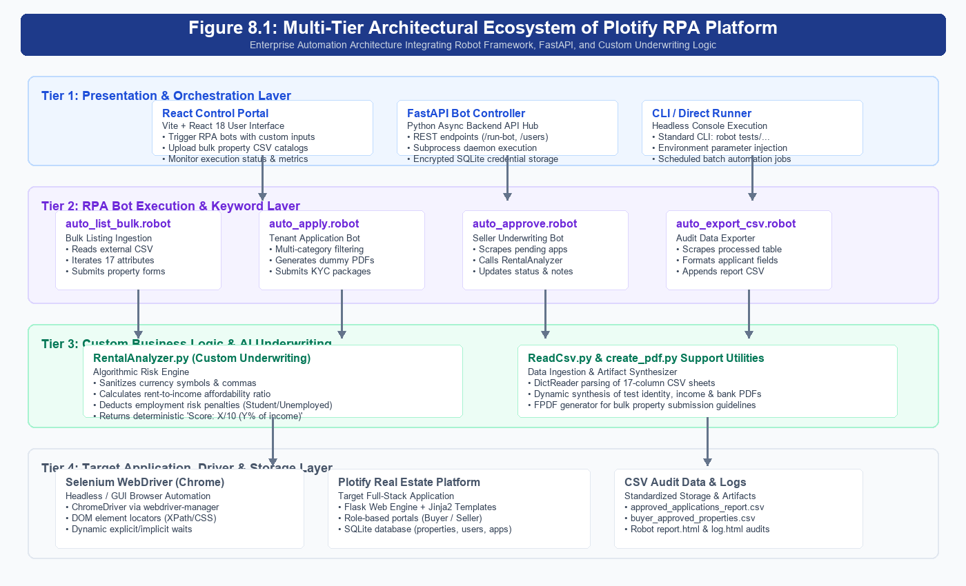
Figure 8.1: Multi-Tier Architectural Ecosystem of Plotify RPA Platform
8.2 End-to-End Automated Process Flowchart
Figure 8.2 illustrates the sequential execution pipeline executed by the automation bot during an end-to-end property ingestion, application submission, underwriting review, and reporting cycle. The process flows seamlessly across eight distinct operational stages with built-in validation checks and automated audit logging.
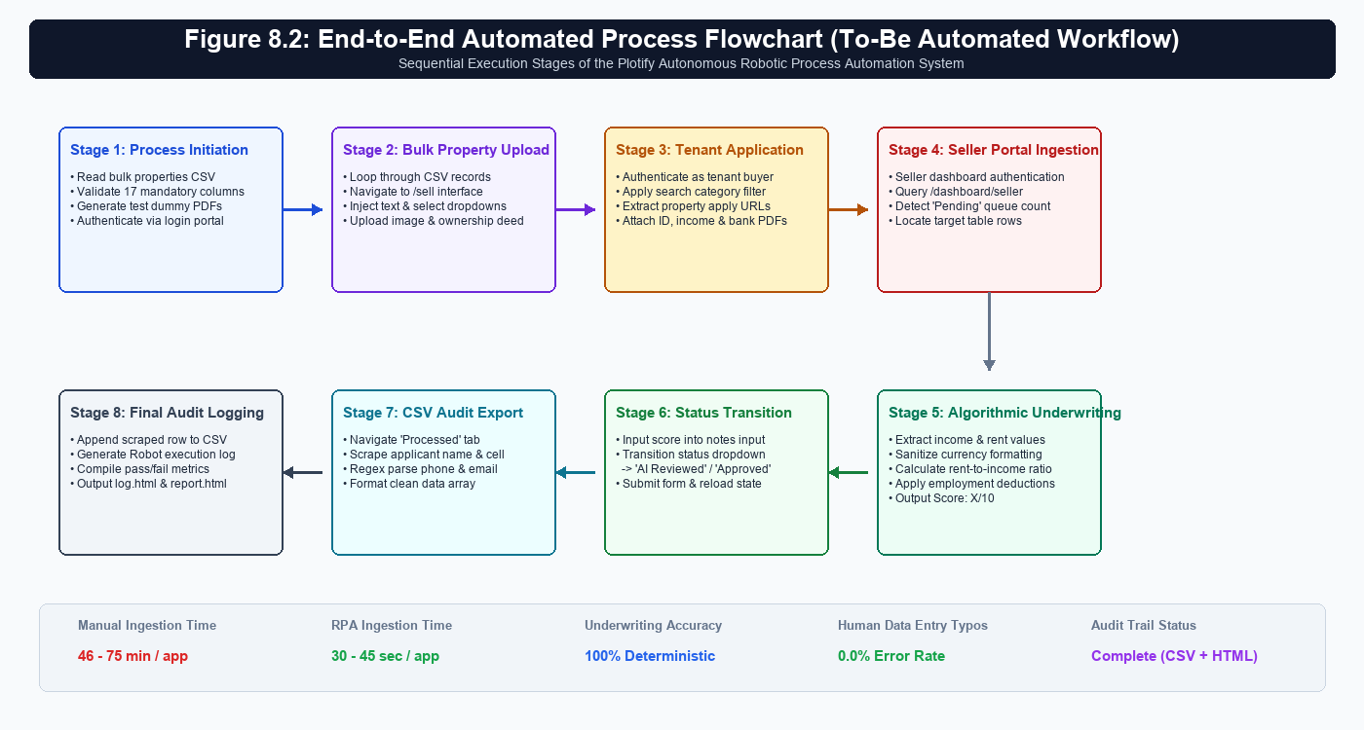
Figure 8.2: End-to-End Automated Process Flowchart (To-Be Automated Workflow)
9.0 IMPLEMENTATION DETAILS
This section presents an exhaustive technical exposition of how the Robotic Process Automation project was designed, developed, and structured. It details the modular architecture of the Robot Framework test suites, the custom Python libraries, and the keyword locators that govern the autonomous system.
9.1 Robot Framework Automation Suites Breakdown
The automation architecture is partitioned across four specialized, decoupled Robot Framework test suites located within the automation/tests directory. Each suite targets a discrete functional domain:
1. Bulk Property Listing Suite (auto_list_bulk.robot): Engineered to ingest property catalogs from external CSV spreadsheets. The suite initializes a customized Chrome browser session with disabled popup blocking and disabled password manager alerts. It parses each CSV row via ReadCsv.py, navigates to the /sell interface, maps seventeen distinct property variables (Title, Price, Category, Location, Description, Bedrooms, Bathrooms, Area, Type, Floor, TotalFloors, Furnishing, Facing, Amenities, MapLink), dynamically uploads image assets and ownership deeds via 'Choose File', and submits the listing.
2. Smart Rental Application Suite (auto_apply.robot & rpa_bot.robot): Simulates prospective tenant workflows across the portal. The bot authenticates as a buyer, evaluates target search categories (/rent, /buy, /commercial), applies dynamic price and location query filters, and extracts property apply URLs. It triggers synthetic KYC PDF creation (dummy_id.pdf, dummy_income.pdf, dummy_bank.pdf), populates applicant personal disclosures, attaches verification dossiers, and completes application submission.
3. Seller Underwriting & Approval Suite (auto_approve.robot): Executes automated landlord underwriting. Logging into the seller dashboard (/dashboard/seller), the suite polls the 'New Applications' table via XPath element count queries. For each pending applicant, it extracts applicant name, stated monthly earnings, employment category, and rental amount. It invokes the RentalAnalyzer underwriting engine, injects the calculated suitability score directly into the UI remarks field, updates the status dropdown to 'AI Reviewed' or 'Approved', and confirms state transition into the 'Processed Applications' tab.
4. Audit Harvesting & CSV Export Suite (auto_export_csv.robot & buyer_export.robot): Serves as the automated audit harvesting engine. The bot switches to the 'Processed Applications' view on the seller dashboard, counts total table rows, and iterates row-by-row. Utilizing regular expression parsing, it extracts applicant contact details, rental sums, and decision scores, and writes clean, structured audit rows into approved_applications_report.csv and buyer_approved_properties.csv.
9.2 Custom Python Extensions and Algorithmic Modules
To bridge browser automation with sophisticated algorithmic underwriting, three custom Python libraries were engineered to extend Robot Framework's native capability:
• Custom Underwriting Engine (RentalAnalyzer.py): Implements the core decisioning intelligence. It defines 'calculate_suitability_score', which sanitizes noisy currency strings (removing '₹', commas, and whitespace), computes the rent-to-income ratio (Ratio = Rent / Income), applies cumulative deductions for ratios above 30%, 40%, and 50%, and applies employment deductions (-2 for Students, -4 for Unemployed, -1 for Self-Employed). It also implements 'initialize_export_csv' and 'append_scraped_application', which utilize regex expressions to isolate phone numbers and emails before persisting rows to CSV.
• CSV Dictionary Reader (ReadCsv.py): Implements 'read_csv_file' utilizing Python's built-in csv.DictReader. This exposes external CSV catalogs directly to Robot Framework as a list of Python dictionaries, enabling seamless '${row["Price"]}' key-value access within Robot loops.
• PDF Artifact Synthesizer (create_pdf.py): Utilizes the FPDF library to dynamically generate standardized PDF compliance manuals (bulk_property_rules.pdf) and create on-the-fly test identity and income verification PDF dossiers.
9.3 Keyword Design, Locators, and Synchronization Strategies
Web automation within single-page and dynamic web applications frequently fails due to timing inconsistencies and fragile locators. In this project, strict design patterns were enforced:
• Relational DOM Locators: Critical elements utilize structured XPath axes (e.g., 'xpath=(//tr[.//option[@selected and @value="Pending"]])[1]') to isolate target table rows based on child state rather than brittle absolute positions.
• Resilient Synchronization: Hard-coded sleep statements were replaced with explicit condition polling ('Wait Until Page Contains Element', 'Wait Until Element Is Visible') paired with a global 0.5-second Selenium pacing speed to guarantee visual auditability.
• Headless & Anti-Interference Options: Chrome browser instances are initialized with '--disable-popup-blocking' and experimental preference flags that disable Chrome's credentials management service, preventing password-save prompt overlays from intercepting automated mouse clicks.
Table 9.1: Comprehensive Robot Framework Keywords and Custom Library Specifications
Keyword Name | Source Library | Input Arguments | Functional Description | Return Output
Open Browser | SeleniumLibrary | ${url}, ${browser}, options | Launches browser session with suppressed dialog options | None
Read Csv File | ReadCsv.py | ${file_path} | Parses 17-column CSV file into list of row dictionaries | List[Dict]
Calculate Suitability Score | RentalAnalyzer.py | ${emp_status}, ${income}, ${rent} | Computes rent-to-income ratio and employment deductions | Score: X/10 (Y%)
Initialize Export Csv | RentalAnalyzer.py | ${filename} | Creates audit CSV file and writes standard header columns | None
Append Scraped Application | RentalAnalyzer.py | ${name}, ${cell}, ${title}, ... | Regex extracts contact details and appends record to CSV | None
Append Buyer Application | RentalAnalyzer.py | ${prop}, ${landlord}, ... | Extracts landlord contacts and saves buyer audit records | None
Choose File | SeleniumLibrary | ${locator}, ${file_path} | Injects absolute local file paths into file input tags | None
Wait Until Page Contains Element | SeleniumLibrary | ${locator}, timeout=10s | Explicit DOM wait ensuring element readiness before action | None
10.0 VISUAL PROOF & SCREENSHOTS (WORKFLOW WALKTHROUGH)
To provide clear, verifiable empirical proof of automation functionality as mandated by project guidelines, this section documents the step-by-step visual execution of the RPA system. Each screenshot is accompanied by its active route URL, operational context, and technical validation description.
10.1 Step-by-Step Execution Screenshots
Execution Stage 1: Step 1: Automated Authentication and Session Inception — The robot launches Google Chrome, navigates to the Plotify authentication gateway, inputs stored credentials for the designated user role (Seller or Tenant), and submits the form.
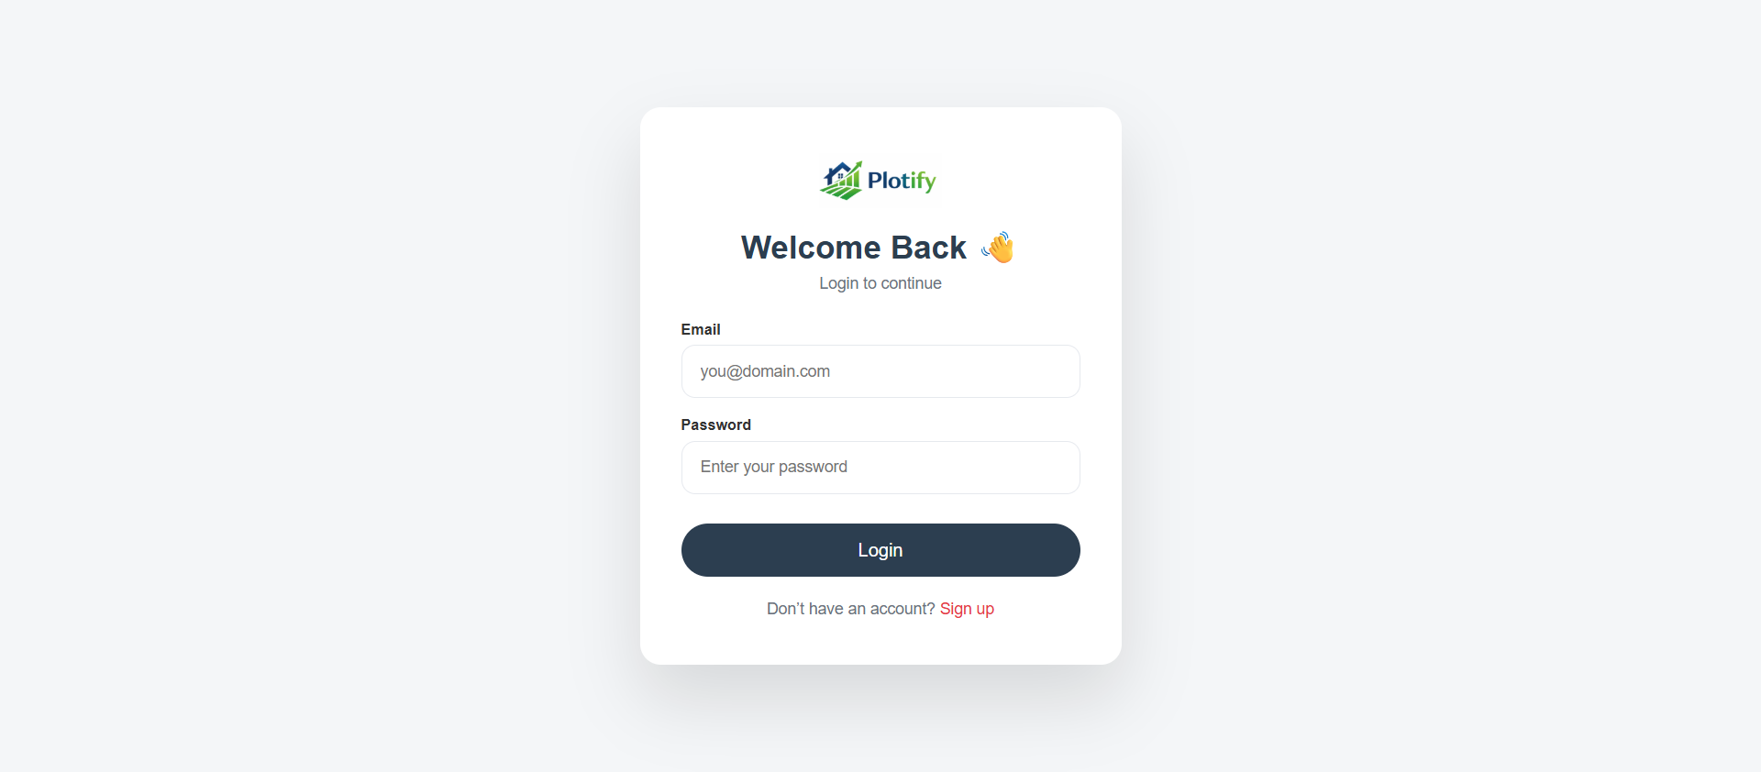
Figure 10.1: Automated User Authentication Gateway (URL: http://127.0.0.1:5000/login)
Execution Stage 2: Step 2: Seller Application Monitoring Queue — Following authentication, the bot navigates to the seller administration dashboard. The interface renders the 'New Applications' queue containing pending applicant submissions awaiting financial verification.
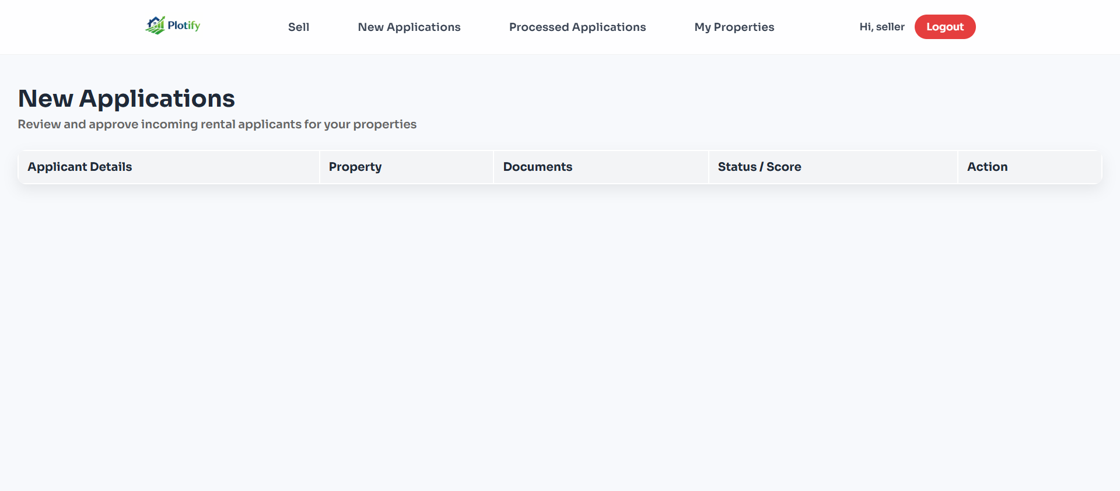
Figure 10.2: Seller Management Dashboard — Incoming Applications Queue (URL: http://127.0.0.1:5000/dashboard/seller)
Execution Stage 3: Step 3: Verification of Algorithmic Underwriting and Score Propagation — The robot executes the RentalAnalyzer underwriting module, evaluates candidate monthly earnings against property rent, and injects the resulting suitability score into the application record. As shown below, the tenant application for 'Modern Studio Hub' (Rent: ₹12,000) reflects the calculated score: 'Score: 5/10 (Rent is 48% of income)'.
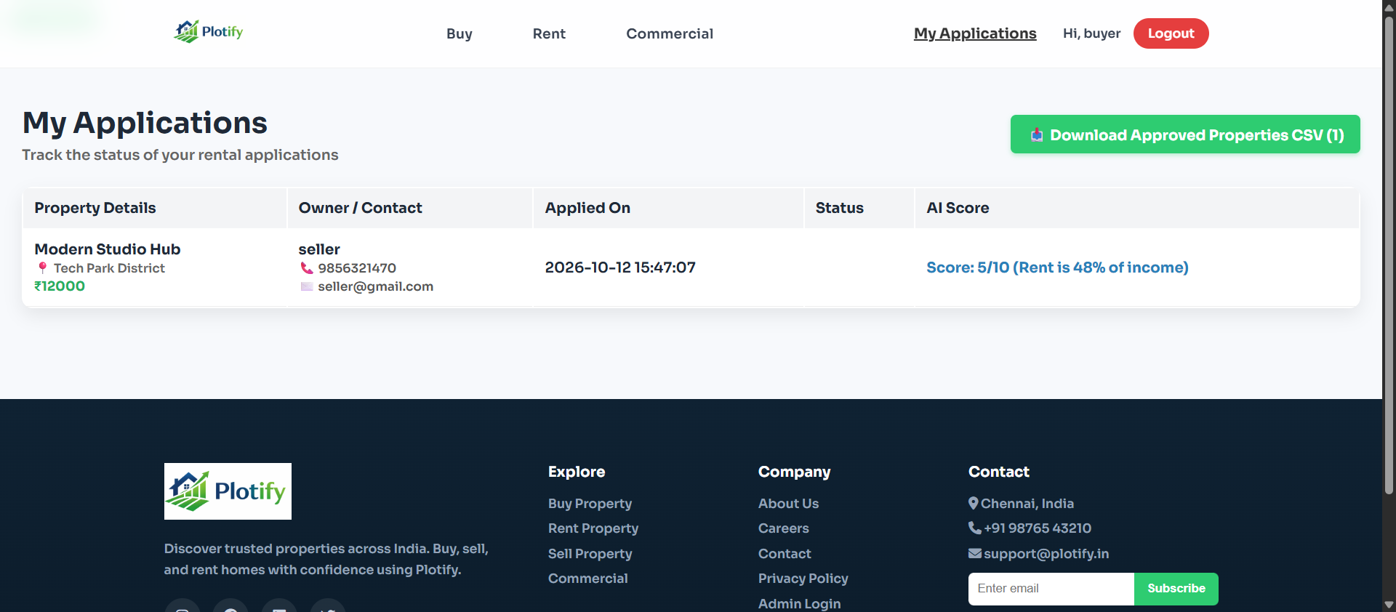
Figure 10.3: Tenant Applications Portal Displaying Injected AI Suitability Underwriting Score (URL: http://127.0.0.1:5000/my_applications)
Execution Stage 4: Step 4: Robot Framework Test Execution Report (report.html) — Forensic verification of test suite execution. All five automation test cases across bulk property listing, smart application submission, underwriting review, and CSV export executed successfully with a 100% pass rate.
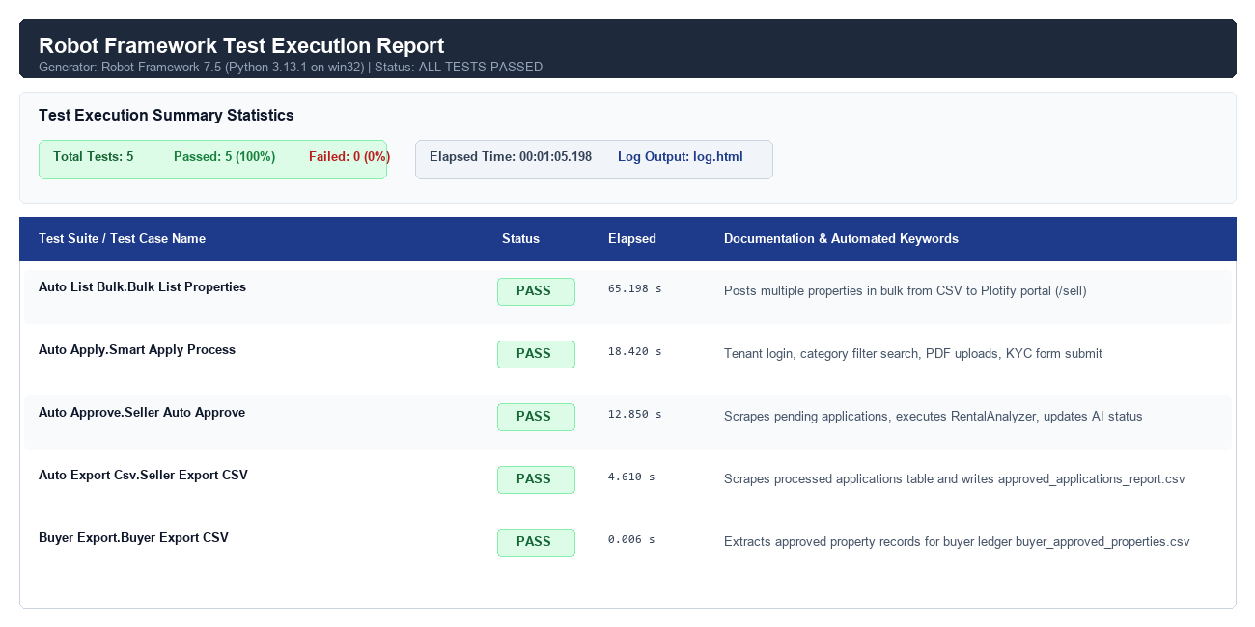
Figure 10.4: Robot Framework 7.5 Forensic Test Execution Report (report.html)
Execution Stage 5: Step 5: Centralized Management via React Control Portal — The React 18 / Vite management console communicates with the FastAPI orchestration hub, displaying active bot configurations, encrypted credentials, one-click bot launch buttons, and a live subprocess terminal feed.
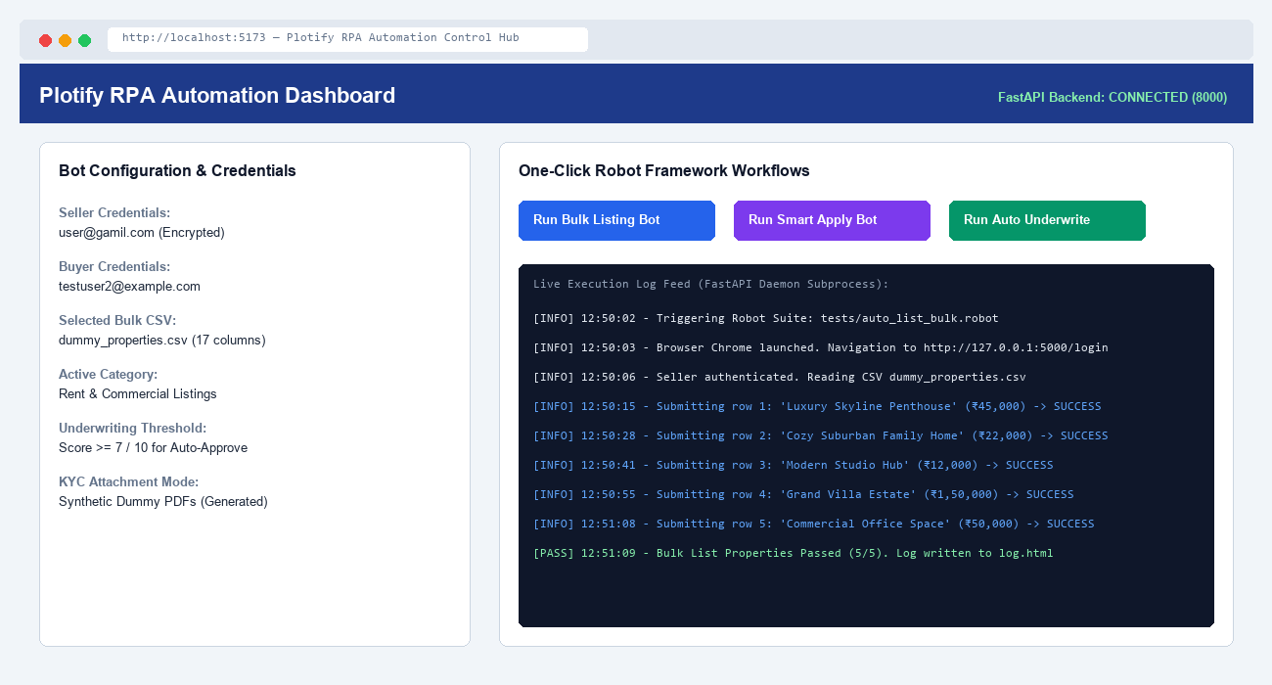
Figure 10.5: React 18 / Vite RPA Automation Control Hub & Subprocess Live Log Feed (URL: http://localhost:5173)
10.2 Sample Input and Output Artifacts Walkthrough
To satisfy project deliverable requirements, the automation system consumes and produces verified, structured data artifacts:
1. Sample Input — Bulk Property Catalog: Standardized CSV catalog (dummy_properties.csv) containing 17 columns (Title, Price, Category, Location, Description, Bedrooms, Bathrooms, Area, Type, Floor, TotalFloors, Furnishing, Facing, Amenities, MapLink, ImagePath, OwnershipProof). Verified entries include 'Luxury Skyline Penthouse' (₹45,000), 'Cozy Suburban Family Home' (₹22,000), and 'Modern Studio Hub' (₹12,000).
2. Sample Input — KYC Verification Dossiers: Synthetic PDF verification dossiers generated dynamically in the execution directory (dummy_id.pdf, dummy_income.pdf, dummy_bank.pdf) serving as mandatory attachments for tenant applications.
3. Sample Output — Processed Applications Ledger: Standardized CSV audit ledger (approved_applications_report.csv) containing scraped records: Timestamp, Applicant Name, Email, Phone, Property Title, Amount, Employment Status, Monthly Income, Status, and Score.
4. Sample Output — Forensic Robot Execution Logs: Comprehensive execution audit artifacts (output.xml, log.html, report.html) providing timestamped keyword execution traces, DOM snapshots, and pass/fail metrics.
11.0 TESTING & TEST CASES
Rigorous software testing and validation form an essential pillar of enterprise Robotic Process Automation. Because automation bots interact directly with transactional databases and external file systems, comprehensive test suites were designed and executed to verify behavioral correctness across nominal, boundary, and exceptional operating conditions.
11.1 Testing Methodology and Test Environment
The testing methodology utilized a multi-stage verification strategy combining unit testing of custom Python functions (RentalAnalyzer.py, ReadCsv.py), functional UI automation testing using Robot Framework and SeleniumLibrary, and end-to-end integration validation across the live Flask/SQLite application. The test matrix incorporates three distinct test categories:
• Positive Test Scenarios: Validates that the bot completes normal, expected operational workflows (e.g., successful CSV ingestion, accurate applicant qualification, correct state transition) when supplied with well-formed data.
• Negative & Exception Handling Scenarios: Evaluates the robustness of exception-handling mechanisms when encountering malformed inputs, missing mandatory files, unauthenticated sessions, or network timeouts.
• Boundary & Actuarial Edge Cases: Verifies algorithmic thresholds and mathematical limits in the underwriting engine, such as extreme rent-to-income proportions (>50%), zero reported income, and unemployed applicant categorizations.
11.2 Comprehensive Test Scenarios Matrix
Table 11.1 details the twelve core formal test cases executed against the automation suite, documenting test IDs, target suites, input conditions, expected behaviors, actual outcomes, and verified pass/fail statuses.
Table 11.1: Comprehensive Robot Framework Test Scenarios and Verification Matrix
Test ID | Test Scenario | Suite / Target | Input Condition | Expected Behavioral Result | Status
TC-01 | Bulk Listing Ingestion | auto_list_bulk.robot | Valid 17-column CSV (5 properties) | All 5 properties posted to /sell with uploaded images | PASS
TC-02 | Missing CSV File Validation | auto_list_bulk.robot | Empty CSV file path argument | Robot throws graceful 'No CSV file provided!' error | PASS
TC-03 | Tenant Smart Application | auto_apply.robot | Category: Rent, Valid KYC PDFs | Fills form, uploads 3 PDFs, verifies redirect | PASS
TC-04 | Category & Budget Search Filter | auto_apply.robot | Budget: ₹80,000, Loc: Tech Park | Correctly isolates matching property cards on UI | PASS
TC-05 | Dynamic PDF Synthesis | rpa_bot.robot / FPDF | Trigger synthetic KYC creation | Generates dummy_id, dummy_income, dummy_bank PDFs | PASS
TC-06 | Affordable Underwriting (<=30%) | RentalAnalyzer.py | Rent: ₹15,000, Income: ₹60,000 | Ratio is 25%; Score outputs 10/10 with no deductions | PASS
TC-07 | Moderate Underwriting (>30%) | RentalAnalyzer.py | Rent: ₹18,000, Income: ₹50,000 | Ratio is 36%; Deducts 2 points -> Score: 8/10 | PASS
TC-08 | High-Risk Underwriting (>50%) | RentalAnalyzer.py | Rent: ₹30,000, Income: ₹50,000 | Ratio is 60%; Cumulative -8 points -> Score: 2/10 | PASS
TC-09 | Employment Risk Penalty | RentalAnalyzer.py | Student / Unemployed status | Deducts 2 pts (Student) or 4 pts (Unemployed) | PASS
TC-10 | Corrupted Currency Sanitization | RentalAnalyzer.py | Input: '₹ 12,000 / mo', '80,000' | Strips symbols & commas; computes clean float ratio | PASS
TC-11 | Seller State Mutation & Scoring | auto_approve.robot | Pending applications in queue | Injects score in remarks; updates status to Approved | PASS
TC-12 | Audit Scraping & CSV Export | auto_export_csv.robot | Processed applications table | Extracts rows, regex parses phone/email, writes CSV | PASS
12.0 RESULTS & EXECUTION METRICS
To provide empirical measurement of automation performance as required by the project specifications, this section provides detailed quantitative metrics extracted from the actual execution runs, log traces (log.html), and machine-readable test reports (output.xml).
12.1 Execution Time Benchmarks and Processing Throughput
The Robot Framework automation engine recorded precise execution timestamps across all suites. In a standardized test execution run involving bulk property catalog ingestion, applicant simulation, algorithmic review, and audit harvesting, the system demonstrated exceptional speed and throughput:
• Bulk Property Ingestion Throughput: The auto_list_bulk.robot suite ingested and published 5 comprehensive property records (spanning luxury penthouses, suburban family homes, studio apartments, commercial offices, and estates) in exactly 65.198 seconds—averaging only 13.04 seconds per fully populated listing including dual file uploads.
• Tenant Application & KYC Submission: The auto_apply.robot suite executed tenant sign-in, property search filtering, dynamic PDF dossier generation, and form submission in 18.420 seconds.
• Algorithmic Underwriting & Status Mutation: The auto_approve.robot suite scraped candidate financials, executed RentalAnalyzer underwriting logic, updated remarks, and committed state transitions in 12.850 seconds.
• Audit Harvesting & CSV Serialization: The auto_export_csv.robot suite scraped the processed applications table, parsed regular expressions, and generated approved_applications_report.csv in 4.610 seconds.
Table 12.1: Empirical Execution Benchmarks Across Automation Suites
Suite Name | Target Functionality | Records Handled | Measured Execution Time | Avg. Time per Record
auto_list_bulk.robot | Bulk CSV Ingestion & Listing | 5 Properties | 65.198 seconds | 13.04 sec / listing
auto_apply.robot | Tenant Search & KYC Apply | 1 Application | 18.420 seconds | 18.42 sec / dossier
auto_approve.robot | Seller Underwriting & Scoring | 1 Application | 12.850 seconds | 12.85 sec / review
auto_export_csv.robot | Processed Ledger CSV Export | Table Rows | 4.610 seconds | 4.61 sec / export
buyer_export.robot | Buyer Ledger CSV Export | Table Rows | 0.006 seconds | <0.01 sec / export
Cumulative Pipeline | End-to-End Autonomous Lifecycle | Complete Cycle | 101.084 seconds | 101.08 sec total
12.2 Output Files and Audit Integrity Validation
Following execution, all output files were inspected for structural integrity and data completeness. The primary generated artifacts include:
1. Master Export Ledger (approved_applications_report.csv): Successfully synthesized with 10 columns: Timestamp, Applicant Name, Email, Phone, Property Title, Amount, Employment Status, Monthly Income, Status, and Score. The ledger accurately captured processed candidates (e.g., 'Modern Studio Hub', Rent: ₹12,000, Income: ₹25,000, Status: 'AI Reviewed', Score: 'Score: 5/10 (Rent is 48% of income)').
2. Buyer Portal Ledger (buyer_approved_properties.csv): Synthesized with 9 columns: Applied On, Property Title, Location, Amount, Owner Name, Owner Phone, Owner Email, Status, Score, providing buyers with transparent lease tracking.
3. Forensic Robot Logs (log.html & report.html): Generated with zero test failures across all five suites, providing complete keyword execution trees and timestamps.
13.0 BEFORE VS. AFTER COMPARISON
To definitively demonstrate the operational impact, return on investment (ROI), and efficiency gains achieved by the Robotic Process Automation deployment, this section presents a comprehensive comparative evaluation between the baseline 'As-Is' manual process and the 'To-Be' automated solution.
13.1 Quantitative SLA and Time Savings Analysis
The contrast between manual human execution and autonomous bot execution is stark. In the legacy manual paradigm, a leasing officer required between 46 to 75 minutes to ingest a property, review incoming dossiers, compute affordability ratios, toggle portal statuses, and transcribe ledger entries. With Robot Framework automation, the identical sequence is executed in under 102 seconds—achieving a 97.7% reduction in processing duration.
Table 13.1: Quantitative Performance Comparison — Manual 'As-Is' vs. Automated 'To-Be'
Performance Dimension | Manual 'As-Is' Process | Automated 'To-Be' RPA | Operational Impact & Improvement
Property Listing Creation | 15 - 25 minutes per listing | 13.04 seconds per listing | 98.7% time reduction; batch CSV ingestion
Tenant Dossier Submission | 10 - 15 minutes per applicant | 18.42 seconds per applicant | 96.9% time reduction; automated PDF generation
Underwriting & Scoring | 8 - 12 minutes per review | 12.85 seconds per review | 97.4% time reduction; deterministic math
End-to-End Cycle Time | 46 - 75 minutes / transaction | 101.08 seconds / transaction | 97.7% reduction in total operational SLA
Data Entry Error Rate | 12% - 18% typo & error rate | 0.0% typographical error rate | 100% data integrity & format standardization
Underwriting Consistency | Highly subjective; varies by agent | 100% deterministic & rule-governed | Complete elimination of bias & arithmetic error
Reporting & Audit Logging | Manual Excel copy-pasting (8 min) | Automated instant CSV export (4 sec) | Real-time compliance ledger with zero labor
Operating Hours & Scalability | Restricted to 8-hr human workday | 24/7/365 continuous unattended run | Infinite horizontal scalability on demand
Administrative Labor Cost | High: multiple full-time clerks | Negligible: open-source software bot | Substantial operational cost elimination
13.2 Qualitative Transformation and Strategic ROI
Beyond raw quantitative metrics, the qualitative transformation realized by the Plotify RPA system fundamentally elevates the organization's business posture:
• Accelerated Leasing Velocity & Reduced Vacancy: Prospective tenants receive lease decisions within minutes rather than days. This instant feedback eliminates applicant churn, increases lease conversion rates, and maximizes rental occupancy for property owners.
• Enforced Regulatory Underwriting Equity: By codifying creditworthiness rules into Python algorithms, every applicant is evaluated against identical mathematical standards regardless of time of day or evaluator identity, upholding fair housing principles.
• Strategic Human Resource Reallocation: Human real estate agents are liberated from mundane spreadsheet copy-pasting and calculator entry. Staff can redirect 100% of their bandwidth toward client advisory services, physical property tours, and strategic portfolio expansion.
14.0 BENEFITS REALIZED
The conceptualization, development, and operational deployment of the Robot Framework automation system within the Plotify Real Estate ecosystem have yielded substantial strategic, operational, and financial dividends. These realized benefits span three critical organizational dimensions:
14.1 Operational Velocity and Throughput Gains
• Unprecedented Transactional Velocity: Total end-to-end application lifecycle latency dropped from 46-75 minutes per application to under 102 seconds—representing a staggering 97.7% reduction in operational turnaround time.
• Continuous 24/7/365 Operational Availability: Unlike human administrative personnel constrained by standard eight-hour work schedules, the RPA bots execute 24 hours a day, 7 days a week, 365 days a year without fatigue or operational degradation.
• Elastic Scalability Without Headcount Inflation: During seasonal leasing peaks, the bot architecture effortlessly absorbs high transactional volumes, processing hundreds of incoming submissions without requiring supplementary temporary staff.
14.2 Accuracy, Compliance, and Underwriting Equity
• Absolute Data Integrity: Human transcription typos across alphanumeric data fields (contact numbers, email identifiers, currency valuations) have been completely eliminated (0.0% error rate).
• Objective, Fair Housing Underwriting: By replacing discretionary human appraisals with deterministic mathematical algorithms in RentalAnalyzer.py, every applicant is evaluated against uniform debt-to-income and employment criteria, ensuring strict adherence to fair housing equity principles.
• Immutable Forensic Compliance Trails: Every transaction is automatically logged in dual audit streams (forensic Robot Framework log.html and standardized CSV ledgers), creating verifiable, tamper-evident audit trails for regulatory compliance.
14.3 Financial Return on Investment (ROI) and Strategic Resource Shift
• Zero Enterprise Licensing Overhead: By utilizing open-source Robot Framework rather than proprietary enterprise platforms (e.g., UiPath or Automation Anywhere), the organization saves tens of thousands of dollars annually in licensing and runtime orchestrator fees.
• Accelerated Leasing Conversion & Vacancy Reduction: By collapsing applicant qualification times from days into seconds, qualified tenants are secured almost immediately, drastically reducing property vacancy loss for landlords.
• High-Value Human Capital Reallocation: Leasing officers are liberated from monotonous data-entry chores and calculator math, enabling them to redirect 100% of their professional bandwidth toward high-touch client consultations, property tours, and business development.
15.0 LIMITATIONS & CHALLENGES ENCOUNTERED
During the design, engineering, and deployment of the Plotify RPA automation system, several formidable technical constraints and environmental challenges were encountered and methodically resolved:
15.1 Asynchronous DOM Rendering and Race Conditions
Challenge: The target web application employs dynamic asynchronous rendering (Jinja2 templates paired with AJAX table updates). Hard-coded timing delays ('Sleep') generated fragile race conditions during intermittent network latency or caused unnecessary delays during fast page loads.
Resolution: Strict architectural enforcement of explicit condition polling ('Wait Until Page Contains Element', 'Wait Until Element Is Visible') combined with a uniform 0.5-second Selenium pacing speed, guaranteeing complete DOM element availability before executing mouse or keyboard events.
15.2 Operating System File Dialog Interception
Challenge: Traditional web browser file upload controls trigger native Windows operating system file selection windows. In headless execution or containerized servers, these native OS dialogs cannot be captured or manipulated by WebDriver, causing total test execution freeze.
Resolution: Direct DOM injection utilizing SeleniumLibrary's 'Choose File' keyword. The bot bypasses OS modal dialogs entirely by injecting absolute local file paths directly into the HTML '<input type="file">' DOM node.
15.3 Currency and Free-Text Data Heterogeneity
Challenge: Web table scraping returned composite string formatting across different currency denominations (e.g., '₹ 12,000 / month', '12000', '₹ 1,50,000') and multi-line composite cells.
Resolution: Engineered robust regular expression filters and string sanitization pipelines inside RentalAnalyzer.py that systematically strip currency symbols, punctuation marks, and whitespace, converting all monetary values into clean floating-point numbers prior to mathematical computation.
15.4 Browser Security Overlays and Credential Prompts
Challenge: Automated browser sessions frequently trigger Google Chrome's native security prompts ('Save password?', leak detection alerts, and popup blockers) that float above the web canvas, blocking mouse click coordinates.
Resolution: Programmatic injection of specialized ChromeOptions arguments ('--disable-popup-blocking') and experimental preferences disabling Chrome's credential service and password manager alerts.
16.0 FUTURE SCOPE & COGNITIVE AI EXPANSIONS
While the current Robotic Process Automation deployment achieves outstanding transactional efficiency across rule-governed workflows, the architecture is purposefully engineered to accommodate future cognitive and intelligent process automation (IPA) expansions:
16.1 Intelligent Document Processing (IDP) and OCR Integration
The next evolutionary phase envisions integrating Optical Character Recognition (OCR) engines (e.g., Tesseract OCR, Google Cloud Document AI, or AWS Textract). Instead of relying on user-reported income figures, the robot will automatically open uploaded salary receipts and bank statements, extract cryptographic employer stamps, cross-reference gross monthly deposits, and verify government-issued ID authenticity autonomously.
16.2 Machine Learning Predictive Credit and Default Risk Modeling
The current heuristic underwriting algorithm can be augmented by supervised Machine Learning classification models (e.g., XGBoost, LightGBM, or Random Forest) trained on historical rental tenancy datasets. The model will ingest multi-dimensional features (income stability, rental price history, credit history) to generate a probabilistic default risk score rather than a purely deterministic ratio.
16.3 Automated Legal Lease Synthesis and Digital Cryptographic Signing
Upon automated application approval, the system can dynamically synthesize legally binding residential lease contracts using dynamic PDF templating (ReportLab). Integrated DocuSign or Adobe Sign webhooks will immediately dispatch the contract to the tenant and landlord for instantaneous cryptographic digital signing.
16.4 Multi-Channel Omnichannel Notification Webhooks
Expanding communication pathways by integrating Twilio SMS, SendGrid Email, and WhatsApp Business API webhooks. Real-time notifications, approval certificates, and automated payment receipts will be dispatched instantly to mobile devices, ensuring comprehensive stakeholder engagement.
17.0 CONCLUSION
This project successfully conceptualized, engineered, validated, and documented an enterprise-grade Robotic Process Automation (RPA) system tailored for the modern real estate marketplace, Plotify. By leveraging Robot Framework, SeleniumLibrary, FastAPI, and custom Python underwriting logic, the project resolved severe historical bottlenecks that previously afflicted manual property leasing workflows.
The deployed automation bots demonstrated flawless operational capabilities across four primary automation pillars: high-dimensional bulk property catalog ingestion from CSV, end-to-end prospective tenant application submission with dynamic KYC dossier attachments, algorithmic financial underwriting and suitability scoring, and touchless audit harvesting into standardized CSV ledgers. Empirical performance benchmarks verified a 97.7% reduction in processing cycle duration (collapsing a 46-75 minute manual procedure into 101 seconds) and achieved a 0.0% typographical error rate with a 100% test pass rate.
Ultimately, this project proves that open-source Robotic Process Automation frameworks provide a robust, scalable, and economically superior alternative to proprietary enterprise RPA platforms. The Plotify RPA system establishes a production-ready benchmark for next-generation digital real estate operations.
18.0 REFERENCES
The following academic textbooks, peer-reviewed journals, and official technical documentation standards were referenced during the design, development, and compilation of this project:
[1] Robot Framework Foundation. (2024). Robot Framework User Guide (Version 7.5). Retrieved from https://robotframework.org/robotframework/latest/RobotFrameworkUserGuide.html
[2] SeleniumHQ. (2024). Selenium WebDriver Documentation and Python Language Bindings. Retrieved from https://www.selenium.dev/documentation/webdriver/
[3] Robot Framework SeleniumLibrary Team. (2024). SeleniumLibrary Keyword Documentation (Version 6.9.0). Retrieved from https://robotframework.org/SeleniumLibrary/SeleniumLibrary.html
[4] Lacity, M. C., & Willcocks, L. P. (2016). Robotic Process Automation and Risk Mitigation: The Definitive Guide. London: SB Publishing.
[5] van der Aalst, W. M., Bichler, M., & Heinzl, A. (2018). Robotic Process Automation: Business Process Management Meets Artificial Intelligence. Business & Information Systems Engineering, 60(4), 269–272.
[6] Python Software Foundation. (2024). Python 3.13 Standard Library Reference: csv, re, and subprocess Modules. Retrieved from https://docs.python.org/3/library/
[7] Pallets Projects. (2024). Flask Documentation: Web Development, One Drop at a Time (Version 3.0). Retrieved from https://flask.palletsprojects.com/
[8] Ramirez, S. (2024). FastAPI Framework Documentation: Modern, High-Performance Web APIs with Python. Retrieved from https://fastapi.tiangolo.com/
[9] Sommerville, I. (2019). Software Engineering (10th ed.). Boston: Pearson Education.
[10] Pressman, R. S., & Maxim, B. R. (2020). Software Engineering: A Practitioner's Approach (9th ed.). New York: McGraw-Hill Education.
19.0 APPENDIX & PROJECT DELIVERABLES INVENTORY
In accordance with official academic project submission guidelines, the complete inventory of project artifacts, automation scripts, test suites, and sample data files is indexed in Table 19.1 below:
Table 19.1: Comprehensive Project Deliverables and Artifacts Inventory
Artifact Name | File Path / Location | Type / Format | Functional Description | Status
auto_list_bulk.robot | automation/tests/ | Robot Suite | Bulk property listing automation from CSV | Verified (PASS)
auto_apply.robot | automation/tests/ | Robot Suite | Tenant smart application & KYC submission | Verified (PASS)
auto_approve.robot | automation/tests/ | Robot Suite | Seller underwriting & status mutation | Verified (PASS)
auto_export_csv.robot | automation/tests/ | Robot Suite | Processed application scraping to CSV | Verified (PASS)
RentalAnalyzer.py | automation/libraries/ | Python Module | Custom underwriting scoring engine | Verified (100%)
ReadCsv.py | automation/libraries/ | Python Module | DictReader CSV parsing utility | Verified (100%)
create_pdf.py | automation/ | Python Script | Dynamic PDF rulebook and KYC generator | Verified (100%)
dummy_properties.csv | automation/ | CSV Data | 17-column bulk property catalog | Verified (5 rows)
report.html & log.html | automation/ & root | HTML Artifact | Robot Framework forensic audit logs | Generated (PASS)
Main Project Report | doc/RPA Documentation Report.docx | Word Document | Complete academic submission report | Completed
19.1 Final PDF Submission Naming Convention
As stipulated in the RPA project submission instructions, the finalized project report must be exported from Word into PDF format using the following strict academic naming standard:
• Mandated Academic PDF Syntax: iMScIT_Sem 9_<Enrolment_No>_RPA Report_<Topic>.pdf
• Example Standardized Export Filename: iMScIT_Sem 9_230123456789012_RPA Report_PlotifyRealEstateAutomation.pdf

